

**Global pipes – challenges for systemic financial infrastructure**

Speech given by

Sir Jon Cunliffe, Deputy Governor Financial Stability, Member of the Monetary Policy Committee, Member of the Financial Policy Committee and Member of the Prudential Regulation Committee

Official Monetary and Financial Institutions Forum, London Wednesday 22 February 2017

It is said that the first 500 years of an institution’s life are the most difficult. By that reckoning, the Bank has 177 years to go before we reach less challenging times.

But at least, with 323 years behind us, we can draw both inspiration and warning from those who have gone before us. In difficult times, I certainly take both from my predecessor, Michael Godfrey.

Godfrey was one of the three co-founders of the Bank in 1694 and its first Deputy Governor. But his tenure was short.

While on Bank of England business in Flanders, in 1695, he sought a meeting with King William III. William was at the time engaged in the 9 Years War and busily laying siege to the town of Namur.

Keen to demonstrate his loyal and fearless service, Godfrey ignored his monarch’s warning that as a central banker in a war zone he should keep his head down. His head was promptly removed by a French cannon- ball.

So when faced with today’s challenges, Godrey’s fate reminds me that previous inhabitants of this post have seen more testing times.

It also remains a salutary lesson that even central bankers should take advice from experts when operating outside their field of competence.

But I also mention Godfrey because the reason he was in Flanders in the first place is relevant to my subject today.

During the 9 Years War, the transfer of money had become extremely hazardous. The newly created Bank of England was therefore tasked by the King to set up an operation in Antwerp in order to transfer funds from London to pay the King’s armies in Flanders.

Godfrey was engaged in cross border money transmission when he met his untimely end.

And that is relevant because I want to talk today about the plumbing, the networks of global pipes for payment, settlement and clearing that make a global capital market and financial globalisation possible.

These now go under the rather grand modern name of “financial market infrastructure”.

The scale, complexity and efficiency of today’s global financial pipes are far beyond anything seen before. Today, more than 64 billion cross border payments are made, and 24 billion cross border transactions are settled every year.1

These global pipes fulfill three functions2:

* international payments systems enable money to move at the click of a mouse – and incidentally mean that central bankers are no longer at risk of getting their heads blown off trying to effect cross border payments;
* international securities settlement enables the ownership of financial assets to change hands quickly and safely, often without the movement or amendment of any physical documentation of ownership; and,
* central clearing systems enable participants in international financial markets to manage the counterparty risks in financial contracts that can last for decades.

“Clearing” of financial activity has a number of meanings. I am here referring to *central* clearing, to the central counterparties (CCPs) that manage the risks of financial contracts rather than to the *clearing* of payments.3

Three points are worth highlighting about this global plumbing.

First, it is true that it is almost entirely private sector built and owned either by their users or as independent profit-maximising companies.

1 Based on Bank of England calculations, using data from 23 jurisdiction. Data from Bank for International Settlements, ‘Statistics on payment, clearing and settlement systems in the CPMI countries: Figures for 2015’. December 2016.<http://www.bis.org/cpmi/publ/d155.pdf>

2 I have excluded Trade Repositories from this list; the Bank does not supervise Trade Repositories.

3 Financial sector participants in a network will have both claims on each other and liabilities to each other. Clearing in its simplest and original form simply refers to mechanisms for adding up each member’s claims and liabilities to the other members before settlement so only the net amount is paid or owed.

The earliest clearing houses were places where banks literally put the receipts recording their respective claims and liabilities on the table at the end of the day so they could be netted off against each other. Such clearing mechanisms still operate in some payment systems though the most important payment systems that settle the highest value payments nowadays operated by central banks work on a gross basis in real time to reduce risk. (Real-time gross settlement of high value payments allows immediate, final and irrevocable settlement of obligations across central bank accounts.) However, we still talk of payments in a currency ultimately ‘clearing’ across the books of the central bank of that currency, for example as in ‘dollar clearing’ across the books of the New York Fed.

Central clearing, however, does not mean the clearing inherent in payment systems but the infrastructure that allows financial market participants to manage the risks they face from their counterparties in financial contracts that can last for months or even decades.

These central counterparties (known as CCPs), originally developed to manage the risks in agricultural commodity contracts, to act as intermediaries, taking and adjusting collateral from both sides to a financial contract so that if one party fails during the lifetime of the contract and cannot meet its obligations, the parties with whom they have traded are protected.

But regulators and central banks however have had quite a hand in the making of these pipes and in mandating their use and terms of access – as a way of reducing risk in the system.

The CLS international payment system, for example, was created by the FX industry, after much prodding from central banks, as a way of addressing regulatory concerns about the level of settlement risk in the system following the failure of Herstatt bank in the 1970s.

Similarly, in response to regulatory demands post crisis, market participants have developed the role of CCPs to enable central clearing of a widening range of financial contracts.

And, in line with their role in encouraging the creation and use of these systems, authorities internationally have long taken a close interest in their regulation and supervision. In 1990 the G10 Governors established the Committee on Payment and Settlement Systems (CPSS), with a membership that was enlarged to include 25 central banks in subsequent years. In 2014, CPSS was renamed to become the Committee on Payments and Market Infrastructures (CPMI).

Second, although there is purely national infrastructure in most countries, the main pieces of cross border financial infrastructure are truly global. For example:

* CLS operating out of New York processes nearly a million FX transactions in 18 currencies for over 60 members worldwide on a daily basis, with an average daily value of $4.9trn.4
* The SWIFT messaging service based in Belgium services more than 11,000 institutions worldwide, operating in over 200 jurisdictions. In 2015 it processed approximately 6.1bn messages.5
* Euroclear, based in Belgium, provides services in 51 settlement currencies for more than 2,000 clients in over 90 countries.6
* Clearstream, based in Luxembourg, serves 2,500 customers in 110 countries, settling more than 250,000 transactions daily.7

4 <https://www.cls-group.com/Membership/Community/Pages/CLSMembers.aspx> <https://www.cls-group.com/About/Pages/default.aspx>

<https://www.cls-group.com/MC/Pages/NewsArticle.aspx?nid=187>

5 [http://www.ey.com/Publication/vwLUAssets/ey-using-swift-as-a-powerful-bank-connectivity-tool/$FILE/ey-using-](http://www.ey.com/Publication/vwLUAssets/ey-using-swift-as-a-powerful-bank-connectivity-tool/%24FILE/ey-using-swift-as-a-powerful-bank-connectivity-tool.pdf) [swift-as-a-powerful-bank-connectivity-tool.pdf](http://www.ey.com/Publication/vwLUAssets/ey-using-swift-as-a-powerful-bank-connectivity-tool/%24FILE/ey-using-swift-as-a-powerful-bank-connectivity-tool.pdf)

6 <https://www.euroclear.com/dam/PDFs/Corporate/Euroclear-Credentials.pdf>

7 <http://www.clearstream.com/clearstream-en/about-clearstream/who-we-are>

* CME Group in Chicago has customers in more than 150 countries and handles 3 billion contracts worth approximately $1 quadrillion annually.8
* Eurex Clearing in Germany has more than 180 clearing members in 17 countries, clearing contracts denominated principally in Euro, and Swiss Franc.9
* LCH SwapClear clears more than 95% of the global cleared OTC interest rate swap market, has over 100 clearing members, over half of which are based outside of the EEA, and clears in 18 currencies.10
* Visa Europe, based in the UK and a subsidiary of Visa Inc, executed all 18.9 billion Visa transactions in Europe in 2015. These peaked at 2,000 transactions per second in the pre-Christmas period.11

And third, although each of the pipes is distinct and serves a discrete purpose, they operate together to provide a seamless global network of functions that Michael Godfrey could not have imagined. The operations behind a routine financial transaction – issuing corporate debt, adjusting a pension fund portfolio or hedging against the risks of commodity price increases – will typically involve a wide range of financial market infrastructure firms over many jurisdictions (see diagram A).

8 <https://www.cmegroup.com/company/files/cme-group-overview.pdf>

9 <http://www.eurexclearing.com/clearing-en/about-us>

10 <http://www.swapclear.com/what/clearing-volumes.html>

11 <https://www.visaeurope.com/enabling-payments/processing>

# Diagram 1: Example of an international commodity hedge

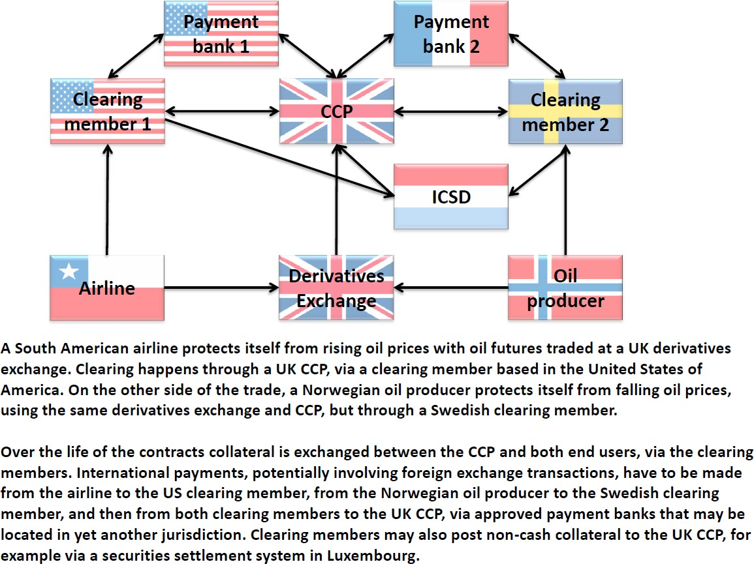

**Diagram 2: Example of equity issuance**

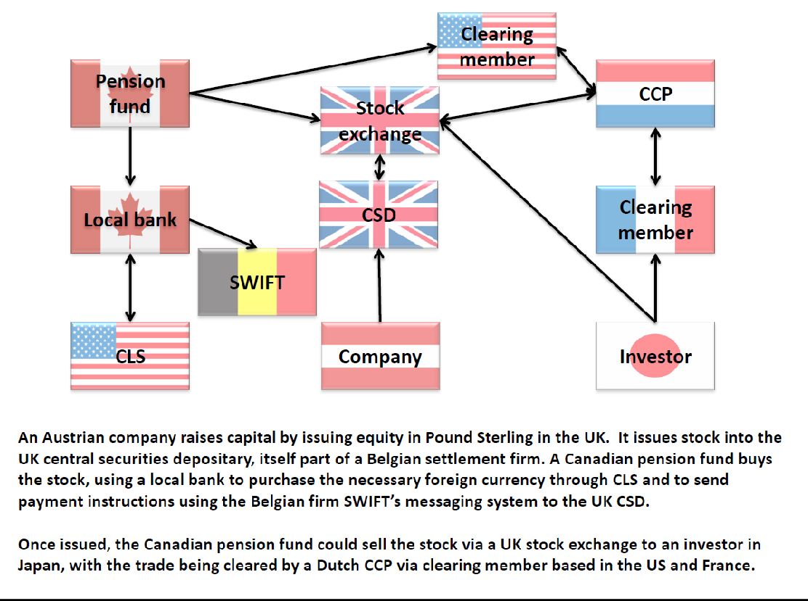

These global pipes have proved pretty robust. In the last crisis financial market infrastructure proved resilient, including during the most testing time of Lehman’s collapse.

But their use is growing, in part because they increase efficiency and lower cost – and in part because they reduce risk and authorities have mandated market participants to use them.12

In line with this, post crisis, authorities internationally agreed that there needed to be a corresponding increase in the regulatory expectations of FMIs.

In 2012 three pre-existing sets of international standards were replaced with the Principles for Financial Market Infrastructure (PFMIs).13

Crucially, the PFMIs embed the principle that firms providing systemically important financial market

infrastructure have a responsibility to be ‘systemic risk managers’ – that is not only managing the risks to the firm but the risks to the system more broadly.

I want to look today at three challenges that are increasingly prominent in this world of international financial market infrastructure –

Operational risk, especially cyber Prudential risk

The regulation and supervision of cross border infrastructure.

There are other challenges, not least the challenges posed to existing business models by new and potentially disruptive technology. But I want to concentrate on the first three because these are front and centre for those charged with ensuring financial stability.

# Operational Risk

It may appear strange to focus first on operational risk. When we think about financial stability, we usually think first about risk taking, about leverage and credit cycles and about banks, booms and busts – risks that one might call prudential.

But in essence, financial stability is about ensuring the financial system can operate to service the real economy and is resilient to all types of shock.

12 Using initial margin as a proxy for the amount of risk managed, activity at UK CCPs has more than doubled in the last three years, from £71bn in January 2014 to £166bn in December 2016.The use of supervised payments systems has also increased significantly. For example, payments processed through Faster Payments grew from 295 million with a total value of £106bn in 2009 to 1,247 million payments with a total value of £1,041bn in 2015.

13 These were developed by the Committee on Payments and Market Infrastructures (CPMI) and the International Organisation of Securities Commissions (IOSCO).

Operational risk is the risk of disruption from systems and processes, from human errors and management failures and from external events and external actors.

All types of financial market infrastructure firms face operational risks. Indeed, for many of these firms, it is the ‘number one’ risk they face.

A serious operational incident affecting one of these global pipes is likely to have an impact on the system as a whole in several jurisdictions, rather than just upon the infrastructure firm itself.

The PFMIs require financial market infrastructure to identify plausible sources of operational risk, and ways to mitigate their impact.14 FMIs are also required to have credible business continuity and recovery plans, with the aim of resuming operations within a maximum of two hours following the most disruptive events.

However, as the infrastructure that supports the financial system grows in scale, complexity and inter-connectedness, the potential risks and costs of systemic operational risks increase as well.

To successfully mitigate this requires a focus on both operational risk and on operational resilience; the ability to respond and recover, as well as prevent and protect. This is well highlighted by the risk presented by cyber-attack.

Last year saw the ‘Bangladesh Bank’ incident in which $81 million of fraudulent payments were effected through the SWIFT network. This has brought to the forefront the need to manage cyber risk not only in the infrastructure firm itself, but also in its surrounding ecosystem of users and intermediaries.

This was an attack on a user rather than on the SWIFT network itself. SWIFT has responded with a customer security programme to reinforce customers cyber defences around their connection to SWIFT and is developing plans for enforcement of the framework.

The Bank of Bangladesh attack had a criminal motivation. It did not bring the system to a halt and, in a narrow sense, one could argue that financial stability was unaffected. I think, however, that would be a complacent view for two reasons. First, the attack risks undermining the credibility of a key piece of global financial infrastructure.

And second, and perhaps more important, the attack highlighted the growing risk from cyber attacks generally, whatever the motivation.

14 PMI-IOSCO: Principles for financial market infrastructure (2012). Principle 17: Operational risk.

The general need for regulators and other authorities responsible for financial stability to give a high priority to operational risk and within that cyber risks has been well recognised. This will not be a one-off effort.

Cyber defences will need to evolve, continuously, to meet the ever growing sophistication of threats.

In the UK, the Financial Policy Committee of the Bank of England (FPC) formally recognised this risk to financial stability in June 2013. It recommended that the authorities should assess, test and improve the resilience of core parts of the UK financial sector to cyber attack.

The FPC has maintained oversight of this programme of work which has included a number of strands, not least the ‘CBEST’ vulnerability testing of critical financial firms and FMIs.15

Improving resilience to cyber risk is one part of the Bank’s wider work on broader operational resilience. Operational resilience is not a technical issue, especially for the infrastructure firms that need to act as ‘systemic risk managers’. It must begin in the boardroom. The Bank has worked with supervised firms to improve governance, so that standards can be maintained or strengthened, and threats responded to, without regulatory or supervisory pressure.

The Bank of Bangladesh incident also shows why, given the critical nature of the services provided by SWIFT, effective international coordination in its oversight is essential.

Oversight of SWIFT is led by the National Bank of Belgium (NBB) as SWIFT is a Belgian company. However, the NBB has for many years conducted the oversight of SWIFT in coordination with other central banks, including the Bank of England.

These arrangements proved important in maintaining the confidence of regulatory authorities worldwide in the aftermath of the attack. And the oversight arrangements have now been extended in scope to cover the implementation of the crucially important customer security programme.

More broadly, the international Committee on Payments and Market Infrastructure (CPMI) has launched a task force to look into the security of wholesale payments that involve banks, financial infrastructure firms and other institutions.16

I will return later to these themes of international cooperation and shared oversight.

15 Record of the FPC meeting held on the 23 and 29 November 2016 <http://www.bankofengland.co.uk/publications/Documents/records/fpc/pdf/2016/record1612.pdf> 16 <http://www.bis.org/press/p160916.htm>

# Prudential Risk

As I have noted, financial stability authorities are more used to managing prudential as opposed to operational risks.

For many of the payment and settlement layers of infrastructure, prudential risks are small. Many FMIs employ no leverage, they typically do not take deposits or investments and they are not primarily engaged in either maturity or liquidity transformation.

The main prudential type risk in the financial infrastructure world arises from the CCPs in the form of counterparty credit risk and liquidity risk.

The development of CCPs for financial contracts is not an accident. It is one of the cornerstones of financial stability reforms that followed the crisis.

The crisis revealed a huge and hitherto opaque network of financial contracts, particularly derivative contracts, held bilaterally between institutions.

As the prices of the underlying financial assets fell and as confidence in counterparties evaporated, banks withdrew trading lines from some counterparties and began to demand increasing amounts of collateral (margin calls) from each other in order to protect themselves.

This acted as an amplifier of stress in the system, leading to further erosion of confidence and a downward spiral in asset prices as banks sold assets to meet demands for collateral.

CCPs are designed to mitigate these risks. They act as the buyer to every seller and the seller to every buyer requiring sellers and buyers to provide adequate collateral (or ‘margin’) in good times to insure against risks in bad times.

They are, of course, by their very objective heavily exposed to the counterparty credit risk of their members. Operational risk apart, the biggest risk they face is that the failure of their largest members would leave the CCP unable to meet its obligations to its other members.

To protect themselves against this credit risk, CCPs demand and hold very large amounts of collateral from their counterparties.

Not all of this collateral is the form of cash.17 It is therefore subject to collateral risk – that is the risk that if one of their counterparties fails in fast moving market conditions the CCP may not be able to turn this collateral into cash.

The PFMI therefore require CCPs accept only the highest quality, liquid collateral and also have a robust and comprehensive liquidity management framework to ensure that they can effect settlement in a timely manner.

From a financial stability perspective, the concern is not simply the risks to the CCP itself. As CCPs are designed to be shock absorbers at the centre of the financial system, damage to a CCP presents risks to the system as a whole.

In order to ensure that what has been designed as a shock absorber does not under stress become a shock transmitter, CCPs not only hold collateral from their members, they are required to hold additional default funds large enough to cover the default of their two largest members. This default fund includes the CCPs own capital. And they are able to call for further resources from their members under their recovery plans if these funds are exhausted.

Notwithstanding the high level of resilience that has been achieved in this area, I think there are three important ‘prudential risk’ challenges for CCPs going forward.

The first is to ensure that CCPs are prudent and require enough collateral, or ‘margin’, from their counterparties in good times to ensure they are protected in times of stress against movement in financial asset prices and in counterparty credit worthiness. CCPs use mathematical models to calculate, on the basis of past and potential market moves, the size of the risks they need to insure against.

Posting margin to a CCP is a cost for a CCP counterparty and its clients. CCPs need strong internal systems and controls to ensure that over time, commercial pressures and competition from other CCPs do not lead to inadequate margining.

It is crucial to ensure that the models that drive CCPs margin requirements are robust, conservative and do not act pro-cyclically. This is an area that, as a supervisor, we look at closely.

The second is to develop further the arrangements for the recovery and, if necessary, resolution of CCPs. I will cover this in the next section.

17 EMIR RTS Article 45.2 requires CCPs to secure not less than 95% of cash collateral with highly liquid financial instruments, thereby limiting the amount of cash CCPs can hold unsecured.

And the third, and perhaps most important, is to develop within CCPs the culture of the ‘systemic risk manager’ - responsible not just for managing the risks to the firm but also managing the risks to the system more broadly.

CCP management, with encouragement from supervisors and regulators, have made significant progress in strengthening their governance and risk culture.

But as the reforms are implemented, as greater use is made of CCPs, as they become more important as a systemic shock absorber, CCP’s management and boards will need to continue to up their game. And we will continue to hold them to account in doing so.

# Regulators and Supervisors

Regulators and supervisors will need to up their game also as the importance of this infrastructure grows.

As I noted at the outset, the international standards – the CPMI-IOSCO Principles for Financial Market Infrastructure - were developed by central banks and regulators in 2012.

In the light of experience and of the growing importance of cross border financial market infrastructure, particularly CCPs, these standards are now being reinforced in two main areas.

First, CPMI-IOSCO has consulted on more granular standards for CCP resilience covering governance, stress testing, coverage and margin, as well as CCP recovery actions. The aim is to ensure both higher standards and greater consistency between jurisdictions.

Second, as part of its work to address the problem of ‘Too Big To Fail’, the Financial Stability Board is developing standards for the resolution of CCPs, to ensure that a failure of a CCP could be resolved in an orderly way.

Given their role, CCPs are by design systemic and need to ensure they handle risk very prudently, particularly the risks from the disorderly failure of their key counterparties – which typically consist of the systemically important global banks. Ensuring that these banks are themselves able to fail safely will reduce the risks to the CCPs of which they are members.

But in the event of such failure, the authorities need to ensure that the CCP’s own recovery actions do not further amplify the stresses already in the system and that losses are apportioned and addressed in the most orderly way.

This month the FSB published draft guidance on CCP resolution and resolution planning. This guidance will be finalised by the G20 meeting this July, with further work on the potential requirements for additional resources in resolution, in 2018.

Supervisors, too, will need to keep pace with the growing importance of financial market infrastructure given its importance to both domestic and international financial stability.

The Bank of England is the supervisor for financial market infrastructure firms incorporated in the UK – including those that provide truly global infrastructure.

The Bank supervises eleven FMIs including some of the largest CCPs in the world (LCH and ICE Clear Europe respectively, by initial margin). As the world’s leading international financial centre, over a quarter of global clearing takes place in the UK.18

We take this supervisory responsibility very seriously – as we do the need for our supervision to keep pace with the growing systemic importance of this infrastructure.

Given London’s role as an international financial centre our aim is to be at the leading edge of supervision of key infrastructure.

Over the past few years we have been reinforcing our capacity and capability precisely to that end. And we will continue to do so.

Our annual report to Parliament will be published today. It sets out how we have discharged our supervisory responsibilities for FMIs over the past year – both through our core assurance programme and our

forward-looking assessment of risks – in order to promote and enhance UK financial stability. It also sets out our priorities for the current year and beyond.

But as well as accountability, we need independent assurance that we are meeting our aim to be at the forefront of effective, forward looking supervision of financial market infrastructure.

Last year the IMF and CPMI-IOSCO published independent reviews of the Bank’s approach to supervision and how far it meets international standards.

CPMI-IOSCO confirmed that the Bank’s approach is fully consistent with the international standards expected of FMI supervisors.

18 On leading international financial centre, see for example ‘The Global Financial Centres Index 20’, September 2016, published by the Z/Yen Group. Global clearing is based on Bank of England calculations using data from CPMI-IOSCO quantitative disclosures in 2016

The IMF’s Financial Sector Assessment Programme review of the UK, concluded that *“supervision of financial market infrastructures (FMIs) in the U.K. has significantly strengthened in recent years; the Bank of England (BoE) is one of the leaders worldwide in shaping reforms in this area”.*19

The Bank is not content with simply confirming that it currently meets international standards as assessed by CPMI-IOSCO and the IMF.

Independent challenge is also why the Bank of England’s Court commissioned an in-depth evaluation by the Bank’s Independent Evaluation Office (IEO) of the Bank’s supervision of financial market infrastructure firms. The IEO report and the Bank’s response are published later today.

The IEO report provides an independent assessment of the Bank’s reinforcement of this area over the past few years, which goes above and beyond international requirements, reflecting the growing importance of this nationally and internationally systemic architecture.

The IEO concluded that: *“Investments made by the Bank in recent years have had the desired effect. Our view is that the Bank is delivering effective, risk-based and forward-looking supervision in respect of FMIs.”*

The IEO report offers a number of important recommendations as to how the Bank can further strengthen its oversight to ensure it continues to keep pace with the growing importance of the infrastructure and the new challenges I have tried to outline today. The Bank welcomes these recommendations and has set out in our published response how we are implementing them.

It is important that all national authorities responsible for globally systemic infrastructure are accountable and subject to evaluation. The CPMI-IOSCO peer reviews and the IMF’s Financial Stability Assessments have a crucial role to play in providing assurance. We also hope that others may also draw lessons from our IEO evaluation.

Higher international standards, robust peer review and evaluation of national authorities are clearly necessary conditions for effective management of the financial stability risks inherent in these crucial global pipes.

But they are not sufficient conditions. As we learned very painfully in the crisis, globally systemic firms require intensified supervisory cooperation between national and where relevant regional authorities.20

19 <https://www.imf.org/external/pubs/ft/scr/2016/cr16156.pdf>

20 The 2008 G20 Communique stated that “…intensified international cooperation among regulators and strengthening of international

standards, where necessary, and their consistent implementation is necessary to protect against adverse cross-border, regional and global developments affecting international financial stability. Regulators must ensure that their actions support market discipline, avoid potentially adverse impacts on other countries, including regulatory arbitrage, and support competition, dynamism and innovation in the marketplace.”

And given their growing importance and cross border nature – machinery for supervisory co-operation in respect of financial market infrastructure firms will become even more important going forward.

Such co-operation is already part of the international standards.21 A variety of supervisory cooperation arrangements exist for financial market infrastructure firms.

I mentioned the SWIFT arrangements earlier. Another example is CLS which is directly supervised by the US as home authority and with a college for representatives of the central banks of the 18 participating currencies.

In the EU, regulatory colleges with statutory powers have been established by legislation on CCPs to bring together the home supervisor of the infrastructure firm and the supervisors of the major financial firms in other EU jurisdictions that use the infrastructure in question.

These of course involve only EU jurisdictions and cannot provide for wider international cooperation. The UK has established global supervisory colleges for its systemic CCPs and has, in recent years, also been the first authority to establish Crisis Management Groups to coordinate resolution planning for the largest CCPs. In the US the CFTC has developed the approach of ‘substituted compliance’ to address this issue.

This is clearly a moving picture. As globally systemic infrastructure evolves, the nature and strength of these co-operative arrangements will need to evolve to reflect the changing nature and scale of cross border risks.

The supervisory and regulatory objective, however, should be to ensure that cross border infrastructure can operate freely while managing the operational and prudential risks.

The evidence so far, is that this can be achieved through shared incentives, dynamic common standards like the PFMI, the assurance provided by peer review and by the IMF – and through a degree of collective oversight and effective cooperation between supervisors and central banks.

There is, of course, another point of view – one that argues that financial stability can only be managed if all transactions and trades in one’s own currency are kept within the borders of that currency.

There may of course be trade or industrial policy reasons for such an approach. And there can also be broader political considerations – surprising as that may seem in the arcane world of international systems for payments, settlements and clearing.

21 CPMI-IOSCO: Principles for financial market infrastructure (2012). Responsibility E: Cooperation with other authorities.

We cannot ignore the fact that such incentives may be at play – now or in the future. But a policy of ‘currency nationalism’ is not a necessary condition for either financial or indeed monetary stability – as is demonstrated by international experience in relation to financial market infrastructure over recent decades.

Such a policy if applied by all jurisdictions is in the end likely to be a road to the splintering of this global infrastructure – and to further fragmentation of the global capital market – rather than the route to the sound and efficient management of risk.

LCH.Ltd, for example, provides central clearing within a single pool for interest rate contracts in multiple currencies – dollars, euros, sterling, yen etc – for financial market participants worldwide.

The single pool allows opposing interest rate exposures in different currencies to be partially offset against each other. This reduces the costs of central clearing – costs that are ultimately borne by the real economy – as well as allowing a more efficient and effective management of the risks that brings significant global financial stability benefits.

Requiring each of these instruments to be cleared in the jurisdiction of the currency in which they are denominated would simply render multi-currency central-clearing impossible.

This is but one example of the very many products in these pipes that are by their nature multi-currency.

In central clearing, in settlement, in payments if we wish to maintain the infrastructure to sustain an open and integrated global capital market, we will need to build upon the arrangements we have developed for supervisory cooperation and co-ordination.

These are not insignificant challenges. But the history of the development of this infrastructure is one of both private and public sector co-operation to provide international plumbing that is both efficient and safe.

# Conclusion

And these challenges may be older than we think.

Less than a mile from here stands the Temple church, built by the Knights Templar in the 12th century. Originally established to protect pilgrims en route to Jerusalem, the Knights Templar soon developed complex international financial operations to store assets and move money across borders.

In London, pilgrims depositing assets in the Temple church received a note that could be redeemed for money when they arrived in the Holy City.

The Templar’s wealth and infrastructure grew enormously – aided by the fact that the Pope exempted them from all regulation, supervision and taxes. One historian has categorised them as the first multinational corporation.

In the end, however, they grew too powerful and the ‘authorities’ of the day in Rome, Paris and London withdrew their ‘authorisation’ and disbanded the order.

Today’s infrastructure, developed to support financial globalisation, exceeds by far anything the Templars – or the first Deputy Governor of the Bank – might have imagined. These global pipes increase efficiency, lower costs to the real economy and reduce risk.

And because they are in essence global, we will have to find co-operative ways to manage the changing risks they present in order to maintain the benefits that they provide.